Configuring an Enterprise Network with Packet Tracer

Starting Topology (student-network.pkt): This is what the network currently looks like.

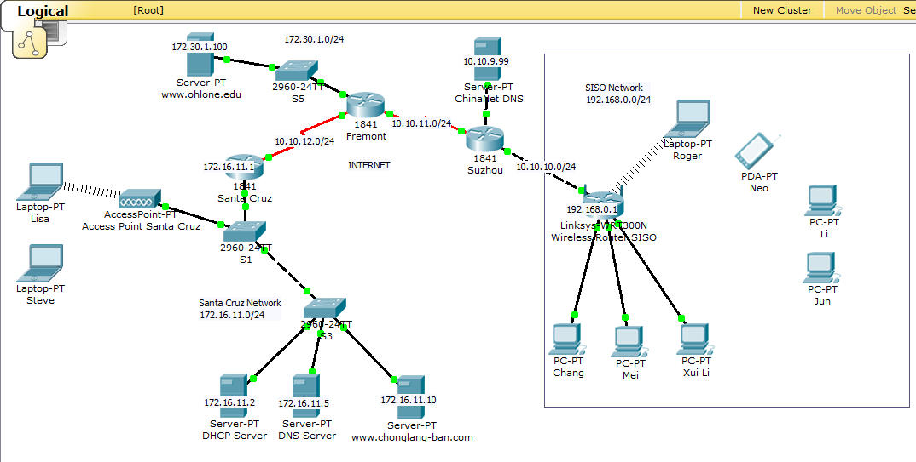

Finished Topology: This is what the network will look like when you are done.

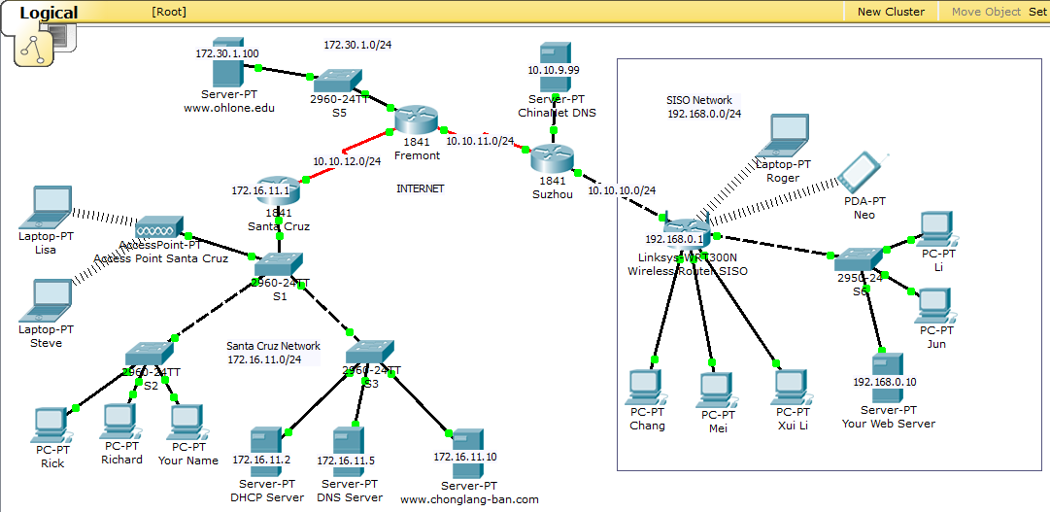

SISO Network

Connect computers for Li and Jun to the network.

Step 1: Add a switch.

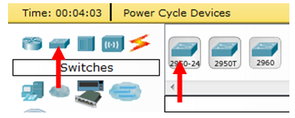

Step 2: Connect the computers to the switch and connect the switch to the Wireless Router.

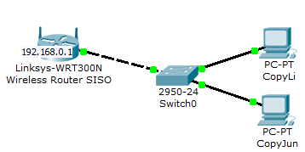

Configure the Wireless Router to be a DHCP Server.

Step 1: Click on the Wireless Router.

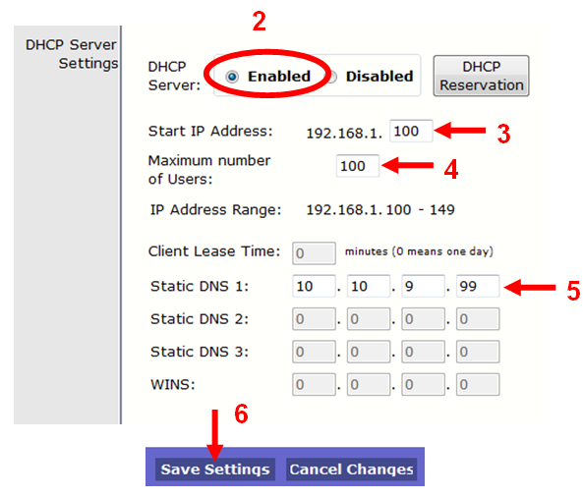
Step 2: After DHCP Server click on the Enabled button.

Step 3: So the computers will get IP addresses starting with 100, after the Start IP Address type 100.

Step 4: Type 100 after the Maximum Number of Users.

Step 5: Change Static DNS 1 to: 10.10.9.99 so the computers will get this as their DNS address.

Step 6: Click on the Save Settings button.
Release and Renew the IP Address on the Linksys Router.

Step 1: Click on Status
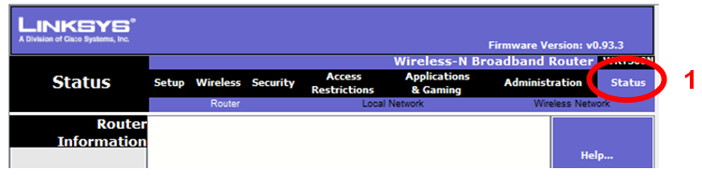

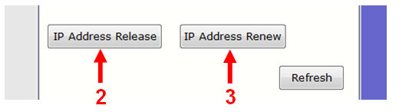
Step 2: Click on IP Address Release

Step 3: Click on IP Address Renew

Configure the SISO computers to use DHCP.

Step 1: Click on each computer and verify that the Settings are for DHCP.

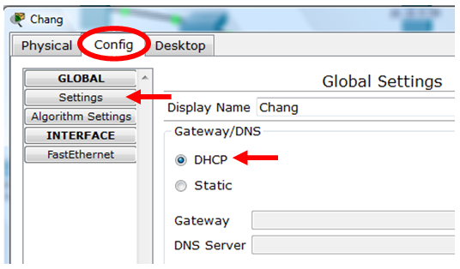

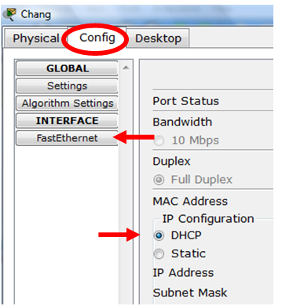

Step 2: Click on FastEthernet and verify that the IP Address is configured using DHCP.
SISO Wireless

Configure the Wireless Router’s SSID Network Name and WPA2-PSK security.

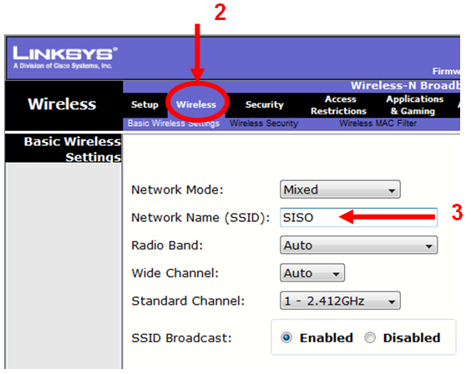

Step 1: Click on the Wireless Router.

Step 2: Click on the Wireless tab.

Step 3: After Network Name (SSID) type: SISO

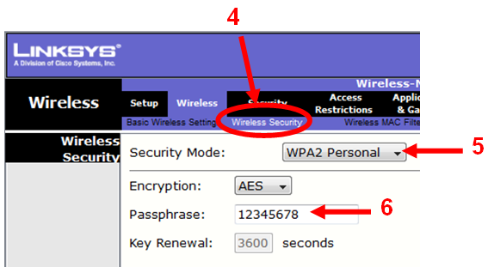

Step 4: Click on the Wireless Security tab.

Step 5: Select WPA2 Personal

Step 6: Type the Passphrase: 12345678

Configure the laptop Roger to connect to the wireless network.

Step 1: Click on the Roger laptop.

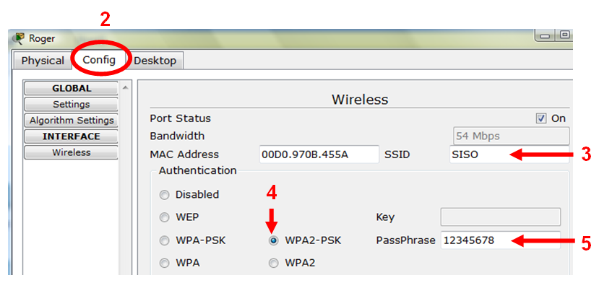

Step 2: Click on the Config tab.

Step 3: Type after SSID (Network Name): SISO

Step 4: Select WPA2-PSK

Step 5: Type in the PassPhrase: 12345678

Verify that Roger’s Laptop and Neo’s PDA can now connect to the wireless router.
Santa Cruz Wireless

Repeat these same steps for the Access Point Santa Cruz and the Laptop Lisa.

Step 1: Click on the Access Point Santa Cruz.

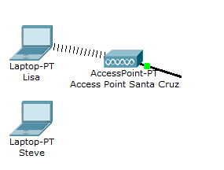
Step 2: Click on the Config tab.

Step 3: Click on Port 1

Step 3: Change SSID to: Santa Cruz

Step 4: Under Authentication select WPA2 Personal.

Step 5: Type the Passphrase: 87654321

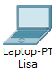
Step 6: Click on the Lisa laptop.

Step 7: Click on the Config tab.

Step 8: Type after SSID (Network Name): Santa Cruz

Step 9: Select WPA2-PSK

Step 10: Type in the PassPhrase: 87654321

Verify that Lisa’s Laptop and Steve’s Laptop can now connect to the wireless access point.

Configure the ChinaNet DNS Server

Step 1: Click on the computer ChinaNet DNS

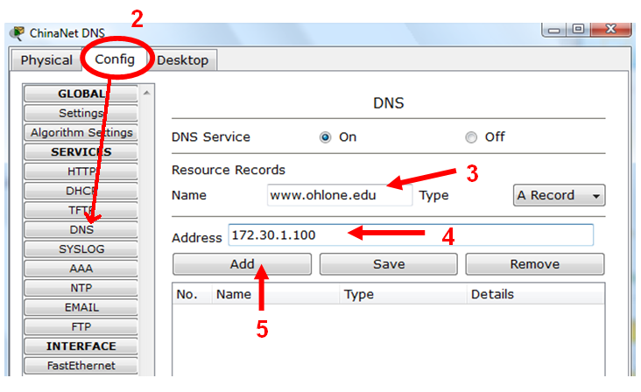

Step 2: Click on the Config tab and select DNS.

Step 3: Type after Name: www.ohlone.edu

Step 4: Type after Address: 172.30.1.100

Step 5: Click on Add

Repeat these steps to add the www.chonglang-ban.com name and address:

Step 6: Type after Name: www.chonglang-ban.com

Step 7: Type after Address: 172.16.11.10

Step 8: Click on Add

Step 9: Click on the computer DNS Server on the Santa Cruz network

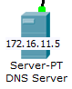

Step 10: Do Step 2 through Step 8 for the Santa Cruz DNS Server.
Use the web browser to go to the web servers.

Step 1: Click on a SISO computer (ex. Chang PC).
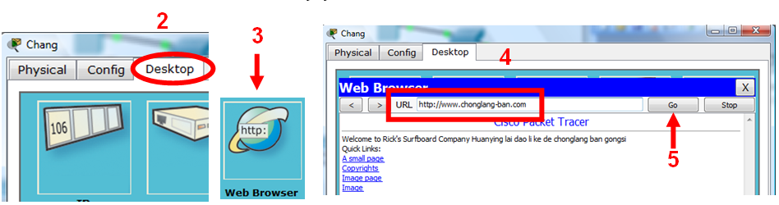

Step 2: Click on Desktop.

Step 3: Click on Web Broswer.

Step 4: Type in the URL: www.chonglang-ban.com

Step 5: Click on Go

You should now see the web page!

Next, try www.ohlone.edu

Modify a Web Page

Step 1: Click on a www.chonglang-ban.com or www.ohlone.edu computer.
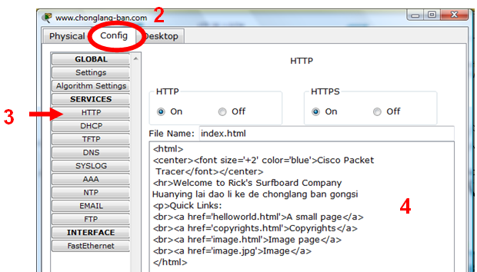
Step 2: Click on Config.

Step 3: Click on HTTP.

Step 4: Edit
Add a switch and computers to the Santa Cruz network

Step 1: Add a switch.

Step 2: Add three (3) computers

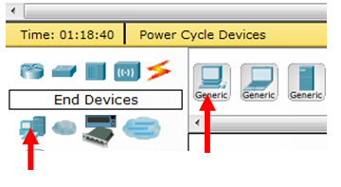

Step 3: Use a straight-through Ethernet cable to connect each host to the switch.

Step 4: Use a cross-over Ethernet cable to connect the new switch to the switch S1.

Step 5: Change the Display Name for each computer to:

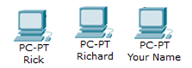
- Richard
- Rick
- Your Name

Step 6: Configure each host to use DHCP.

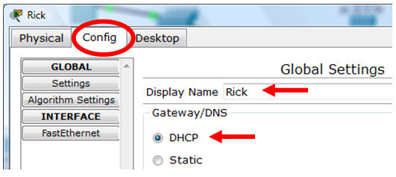
EXTRA CREDIT

On the SISO network create a new web server.

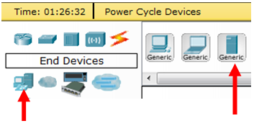

On the Web Server:
- Turn off DHCP.
- Configure the static IP address 192.168.0.10 and subnet mask 255.255.255.0.
- Configure default gateway 192.168.0.1 and DNS server 10.10.9.99.
- Edit HTTP HTML.
- Connect to switch.

On the ChinaNet DNS Server
- Enter the IP Address of the new Web Server.
- Create a Domain Name that you would like to use (www.___________.com)
- Add the record.

From

NOTE: You can only access this web server from a host inside the SISO Network. This has to do with NAT (Network Address Translation). You can search for this if you want more information or ask Richard or Rick.

